**FERTILIZER PREDICTION**

**Introduction**

India is the leading producer crops and the lack of fertility is The reasons are lack of irrigation facilities, improper pest management, soil erosion due to natural calamities. The Machine learning algorithms like regression algorithms are used to predict the crop yield based on fertilizer consumption. This helps the farmers to decide the quantity of fertilizer to be used in the cultivation. Simple Linear regression model involves one predictor variable. Multiple linear regression model involves more than one predictor variables.

**Objectives of Research**

This project is aimed at developing a suitable fertilizer for the farmers to yield the crops and to maintain the fields in the proper manner. We can decide the pests that should be used in according to the crop and soil type by using this machine learning techniques.

**Problem Statement**

To predict a suitable fertilizer that yields profitable results for a given plant soil combination with the help this fertilizer prediction.

This fertilizer prediction is useful for the farmers to make a decision that what time which pest should be used. They can get a conclusion based on their soil and crop type.

**Review of literature**

the

**Data Collection**

The data should be collected from the different areas of field and should be tested. Whenever the crop has to be changed.

The data in the file are: Soil type, temperature, humidity, moisture, crop type, nitrogen, phosphorus, potassium and the main inputs are the soil type and crop type. The predicted output was the fertilizer name.

**Methodology**

**Exploratory Data Analysis**

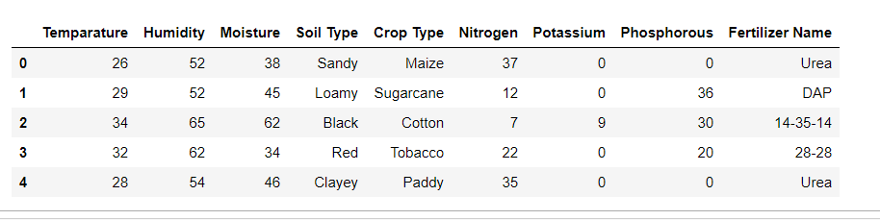

The above is the correlation table. As we can observe that the fertilizer changes when the temperature, soil type and crop crop type changes.

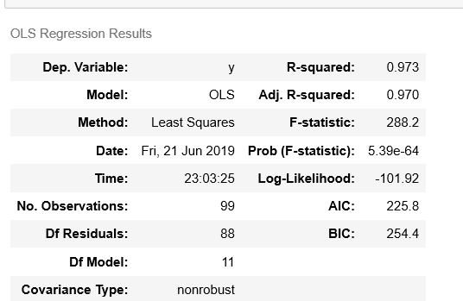

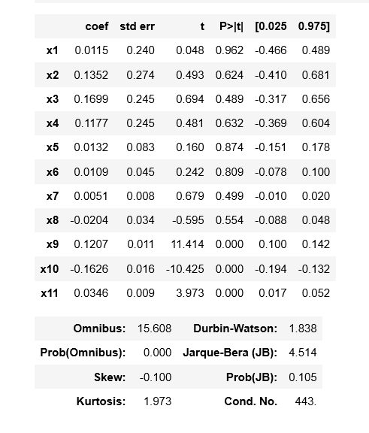

* R-squared - explain the amount of variance of the model. As for the good model it should be high, we got 0.973.
* Adjusted Rsquare - Goodness of fit(). We got it as 0.970 which is almost high. Hence this is a good model.
* p>[t] - Probability Test. Since it is < 5% Alpha (0.05) then REJECT Null Hypothesis. Since, there is a significant relation between the attributes.

**Data Modelling**

The data set is of Supervised Machine Learning which means there is a target variable which is fertilizer name . As the target variable is a continuous attribute. Hence, Regression model has to be used to get the accuracy of the model. Also more than one input we use decision tree Model to predict the out put.

**Conclusion**

Analyzing the large sets regularly results in returning the sustainable fertilizer to the framer. The best fertilizer based on yield rate are being researched that fits exactly for the problem.